**How to overflow tables?**

1. If the object is wrapped in subform change the content to flowed first

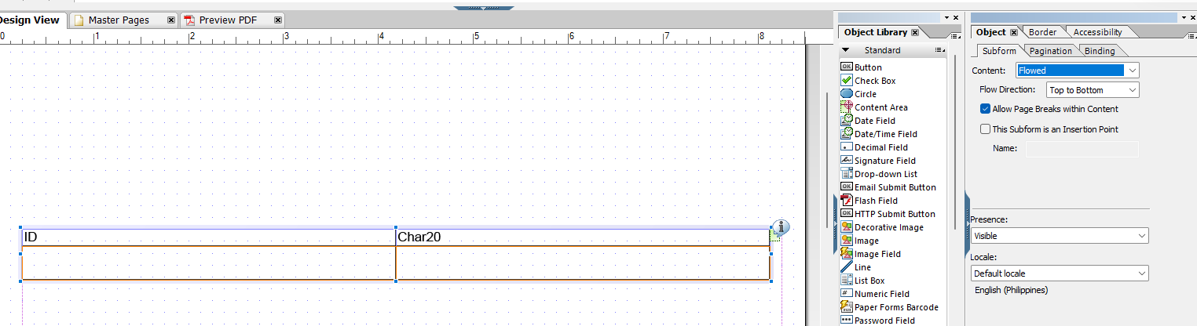

1. Select the tables/subform then in pagination tab select the content area where should it overflow

